Amelia’s Website Changes
HOME PAGE
Logo – My name is misspelt should be Amelia vs Ameilia. It is across the top and bottom
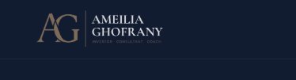

Key words – I am no longer promoting Coaching Services so would like to remove this from across the site:

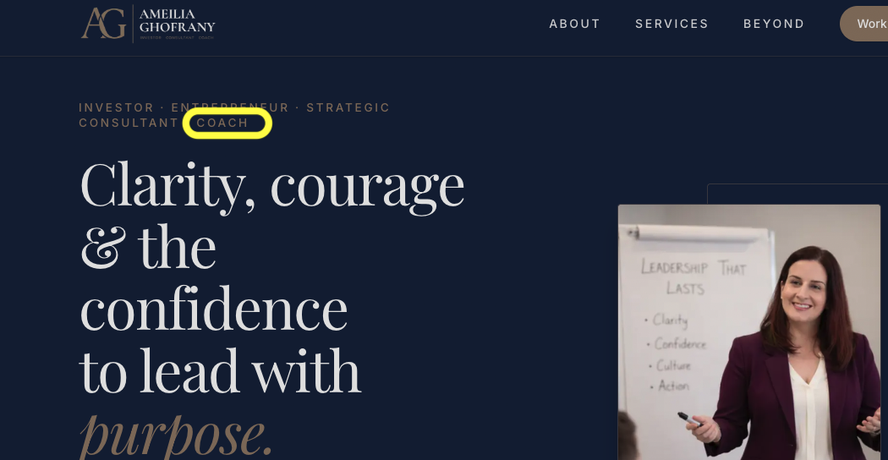
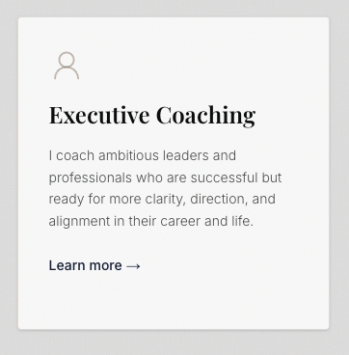
Headline should now say: “Investor. Strategic advisor. Speaker.”
Sub-head: “I buy and build Australian businesses, help their leaders make sharper calls, and speak on what it actually takes to lead with purpose.”
One line per hat, to sit under the hero or in the four wayfinding cards:
- Investor: “Actively acquiring $5–20M turnover Australian businesses, industry-agnostic, with creative deal structures and no ego about who gets the credit.”
- Strategic Advisor: “Founder and Managing Director of Compasspoint Advisory, built from scratch to serve SMEs and family enterprises. 20-plus years turning strategy into decisions that actually get made.”
- Speaker: “Keynotes and panels on purpose-led leadership, women in business, and what diverse perspectives really change.”

Social Media
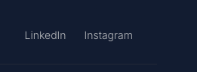
The LinkedIn link in the home page doesn’t work, the address is https://www.linkedin.com/in/ameliaghofrany/ also the Instagram link also doesn’t work. Link is: https://www.instagram.com/ameliaghofrany/
I wonder if I should include my Linktree as that includes all my links as well: https://linktr.ee/ameliaghofrany?utm_source=linktree_profile_share&ltsid=90287e54-0f69-4f3d-82b5-17a8c4a60beb

Contact Form – Can we add a contact form section so people can send through their queries instead of booking a call?

Compasspoint website link – The links to the Compasspoint website still point to the vercel link and not to www.compasspointadvisory.com. Not sure if you will update this once its published:
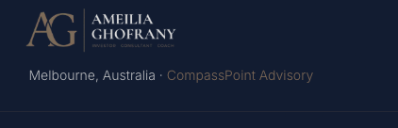

Quote – I like the quote and layout but I find it hard to read because of the gradient. Also is this suppose to be a quote I say or is this someone else’s?
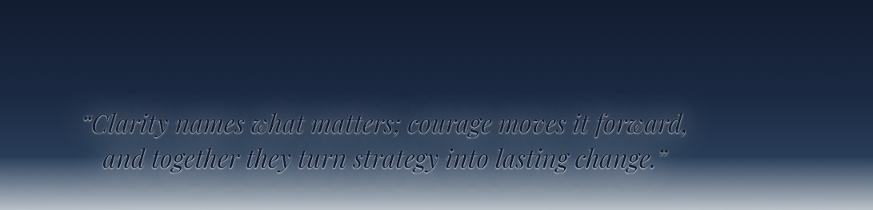

Photos of Me
I know I need to get new photo shoot done that makes me stand out and be more personable but for now we can use existing ones we have.
As this is my personal brand my photos need to be more prominent and integrated in the website.
I like this photo however its small on the screen as the audience needs to get to know me then I think it needs to be a little bigger:
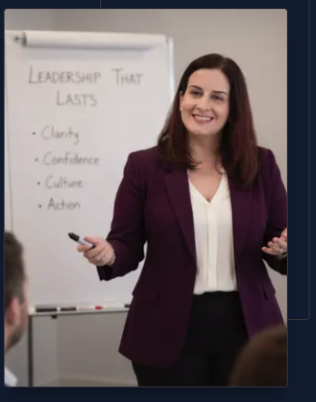
I also like this photo from my original website as I feel makes me both personable and yet business like with the computer:
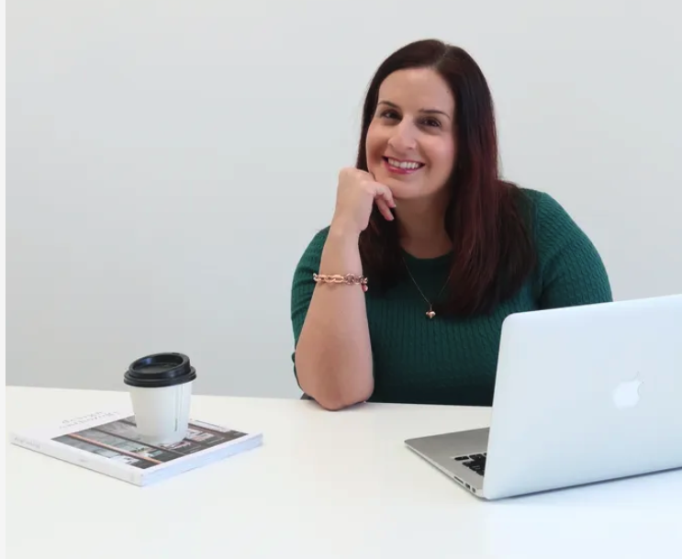
This one is ok too:
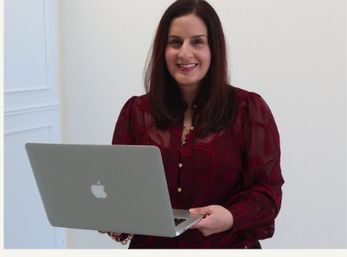
I generally use this photo when doing speaking engagements or bios:
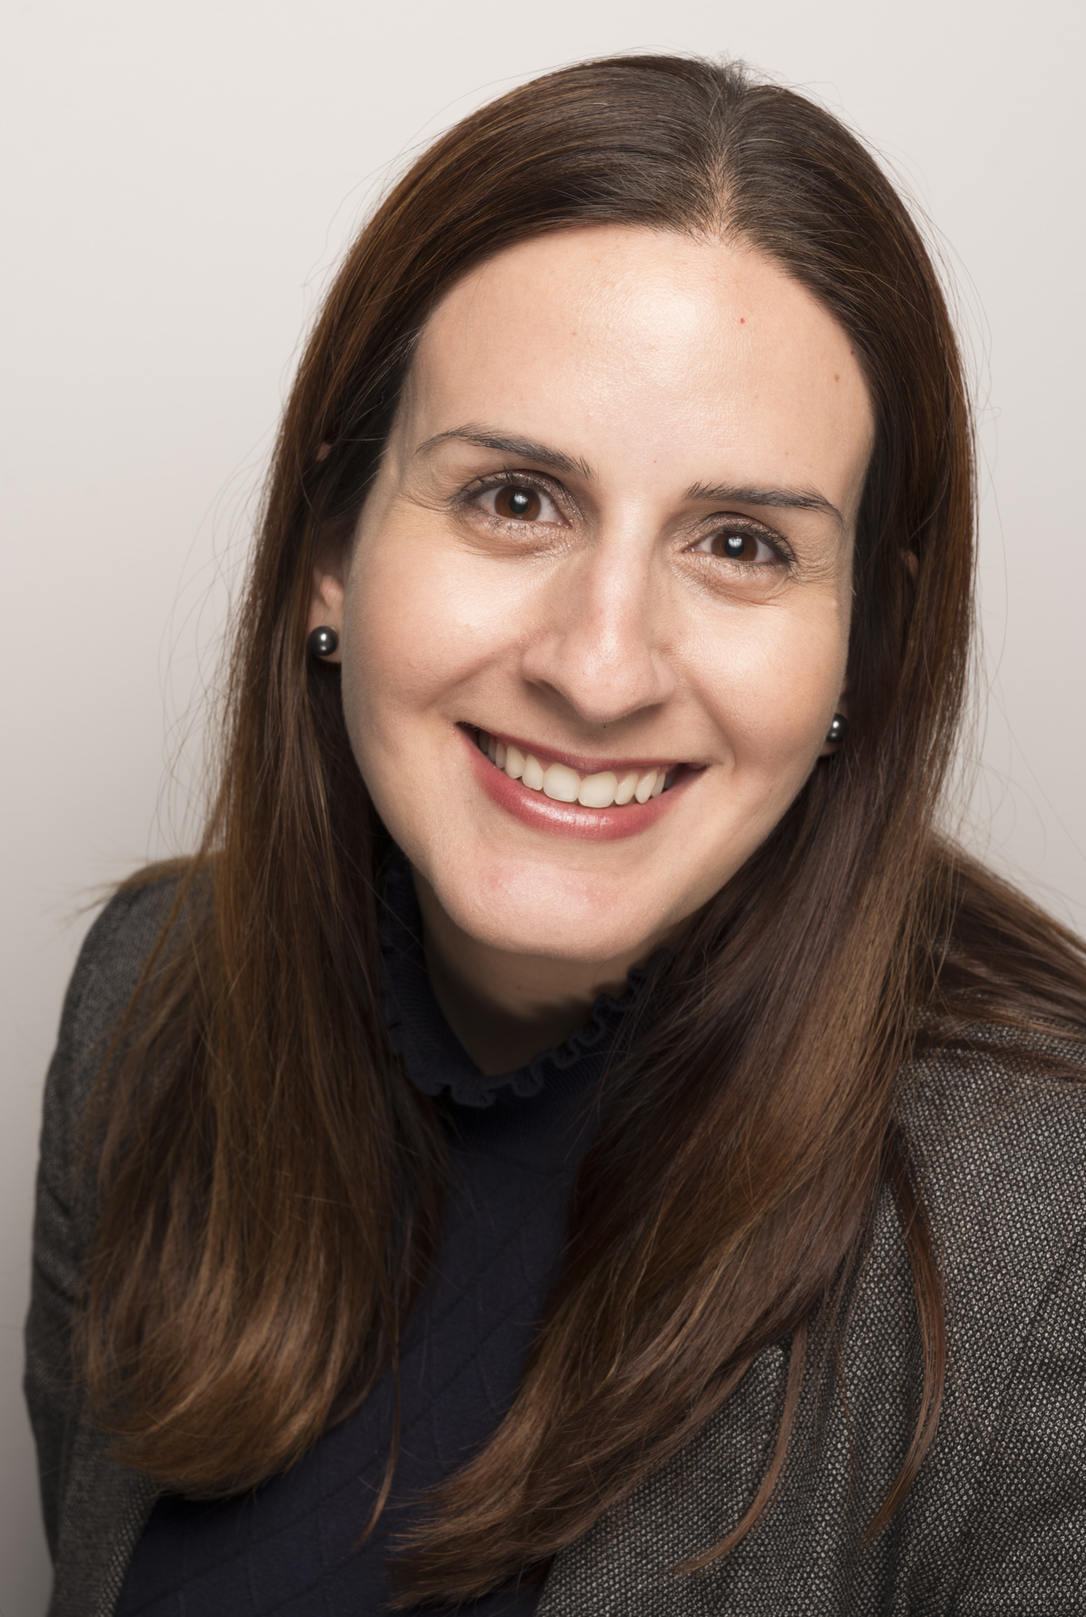

I don’t like this photo of me:
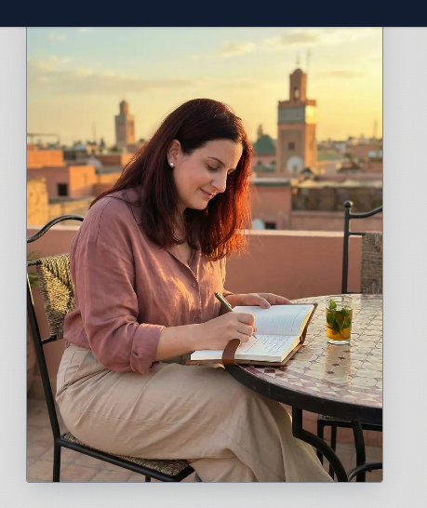
I would rather have a picture of the world or travel scenery.

About Me Bio
Please update the about me to this version:

I was born in Peru, of Persian heritage, and have lived most of my life in Australia, with three and a half years in Israel during my twenties. Those cultures shaped who I am and how I lead.
I speak English, Spanish and Farsi fluently, get by in French, and can follow Portuguese and Italian through their closeness to Spanish. I've worked and lived across three continents, travelled to 26 countries, and that comfort with difference is exactly why I believe, not just say, that diverse perspectives change outcomes.

I've spent over 20 years helping organisations lead through complex change, bringing people, processes and technology together to deliver sustainable growth, exceptional customer and employee experiences, and meaningful impact.
Today, I partner with businesses of all sizes, from ambitious startups to large enterprises, to help them transform and scale with purpose. Through my company, CompassPointAdvisory (WEB LINK), I offer practical, forward-thinking strategies grounded in real-world experience.
Whether I'm consulting, investing or speaking, I bring curiosity, courage and a strong belief in inclusive leadership. I've built businesses from scratch, advised executive teams, and led major digital transformation programs across industries.

Outside work, I'm a curious traveller and, as a Bahá’í, get involved in community projects close to my heart — including advancing women in leadership and building ethical, purpose-led businesses.

Testimonials
Please repeat the ones from compasspoint website here.

Services
Given the 3 areas I am only focusing on we can keep to just the three boxes of Strategic Advisory, Investor and Speaker. The Strategic Advisory can ultimately lead to the compasspointadvisory site.

Blurb on Strategic Advisory:
Most of my strategic advisory work happens through CompassPoint Advisory, the practice I founded to help SMEs, founders and family enterprises grow and transform. I've advised executive teams and led major transformation programs across organisations like the ATO, Qantas, Commonwealth Bank and NAB — but I set up CompassPoint Advisory because I believe strategy changes lives most at the SME level, not just in big corporates.
My approach is values-led and practical: plain advice that gets acted on, not a deck full of options you'll shelve. Whether you're navigating growth, a transformation, or a decision you can't quite call, I bring curiosity, real operating experience, and the courage to tell you what I actually think.
For the full range of services, or to see how I work with clients, visit Compasspoint Advisory (Link).

Blurb on Investor:
I invest in businesses at different stages, and in different ways. Sometimes that means acquiring a business outright. Other times it's partnering with an existing business to help it grow, scale or transform. And for the right startups, it can mean backing the founders with my strategic experience and mentoring in exchange for equity.
However we work together, I bring the same thing: curiosity, hands-on experience building and running businesses, and a genuine interest in your success, not just the deal.
Every situation is different, so the best next step is a conversation. Get in touch or book a time to talk through where you're at.

Blurb on Speaker:
I'm available for keynotes, panel discussions, workshops and podcasts, sharing insights on women in leadership, business growth, and driving meaningful change. I speak from experience, not theory — twenty years advising executive teams, building a business from scratch, and backing founders has taught me a lot about what moves people and organisations forward.
If you're looking for someone who'll bring a genuine point of view rather than a rehearsed talk, I'd love to hear about your event.
Get in touch to check availability and talk through what would work best for your audience.

Contact Info:
Create a email contact enquiry page.

